
Home Inspection Report

1234 E. Main St., Yourtown, AZ

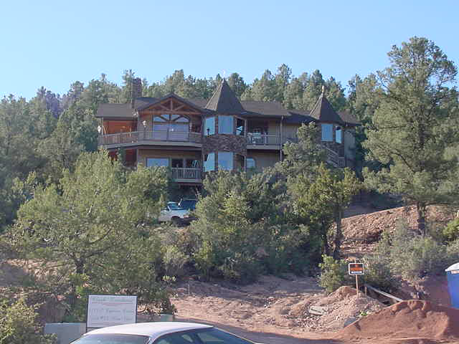
Inspection Date:
1 January 2002

Prepared For:
Mr. & Mrs. Buyer

Prepared By:
Homewerx, Inc.
P.O. Box 1976
Gilbert, AZ 85299-1976
(480) 503-2611
(480) 813-8949 Fax
Homewerx@qwest.net
www.home-werx.com

Report Number:
Sample

Inspector:
Inspector

© 2026 Homewerx, Inc.

